**NAME** :- Manish Shashikant Jadhav

**UID** :- 2023301005.

**BRANCH** :- Comps -B. **BRANCH:** B.

**EXPERIMENT 8: Implementation of Direct Mapping.**

**SUBJECT** :- CAO (COMPUTER ARCHITECTURE AND ORGANIZATION)

**CODE :-**

import java.util.*;

class Memory{

Scanner sc = new Scanner(System.in);

int bs,mm,cm;

int bsarr[]=new int[100];

int mmarr[]=new int[100];

int cmarr[]=new int[100];

public Memory()

{

System.out.println("Enter block size:");

bs = sc.nextInt();

System.out.println("Enter main memory size:");

mm = sc.nextInt();

System.out.println("Enter cache memory size:");

cm = sc.nextInt();

mem_map();

}

void mem_map()

{

int no_of_blocks = mm/bs;

int no_of_lines = cm/bs;

int bi=get_power(no_of_blocks);

int ci=get_power(no_of_lines);

String main_mem[]= new String[no_of_blocks];

String cache_mem[]= new String[no_of_lines];

System.out.println("Displaying Main memory");

for(int i=0; i<no_of_blocks;i++)

{

String display =new String();

display=Integer.toBinaryString(i);

display=prec_zero(display,bi);

main_mem[i]=display;

System.out.println(display);

}

System.out.println("Displaying Cache memory");

for(int i=0; i<no_of_lines;i++)

{

String display =new String();

display=Integer.toBinaryString(i);

display=prec_zero(display,ci);

cache_mem[i]=display;

System.out.println(display);

}

String block_no = new String();

System.out.println("Enter the block no to be mapped in binary:");

sc.nextLine();

block_no = sc.nextLine();

String lsb= new String();

int j=bi-1;

for(int i=ci-1 ; i>=0 ; i--)

{

char c = block_no.charAt(j);

lsb=c+lsb;

j--;

}

System.out.print("Block no "+block_no+" will be mapped to line no: ");

System.out.println(lsb);

String tag = new String();

int k=bi-ci-1;

for(int i=k ; i>=0 ; i--)

{

char c = block_no.charAt(i);

tag=c+tag;

}

System.out.print("Tag bit of "+block_no+" is: ");

System.out.println(tag);

}

int get_power(int n)

{

int ans=0;

while(n!=0)

{

n=n/2;

ans++;

}

return ans-1;

}

String prec_zero(String str, int bi){

int len = str.length();

for(int i=0; i<bi-len ;i++)

{

str="0"+str;

}

return str;

}

}

class Main {

public static void main(String[] args) {

Memory m = new Memory();

}

}

**OUTPUT** :-

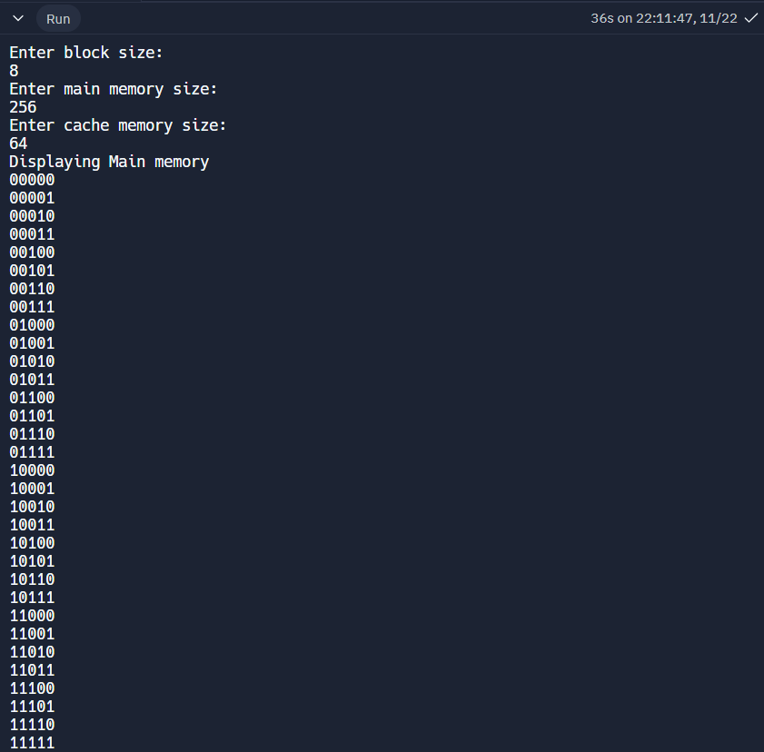

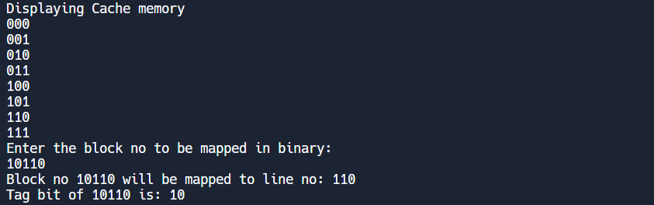

**Conclusion:** Hence by completing this experiment I came to know about Direct Mapping.